2017 Kessler Foundation National Employment and Disability Survey:

Supervisor Perspectives

Executive Summary

Synopsis. The key findings of the 2017 Kessler Foundation National Employment and Disability Survey: Supervisor Perspectives (KFNEDS:SP) show that employers are striving to recruit, hire, train, and retain people with disabilities in their organizations. Supervisors provided information about the most-used employer practices, the most effective practices, and emerging practices that show promise of improving employment for people with disabilities.

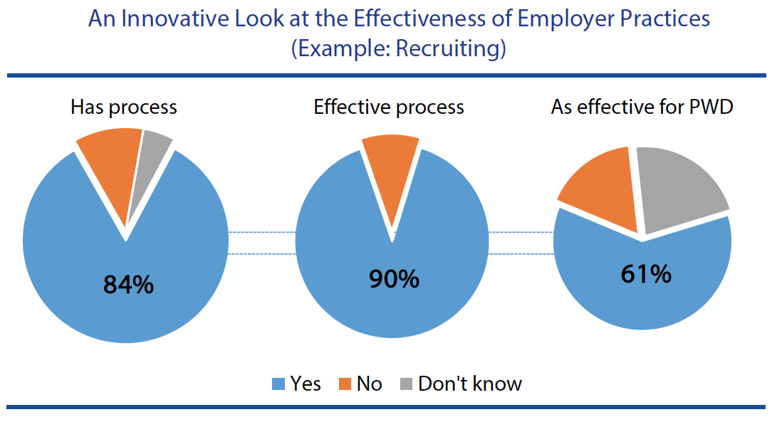

Objective. The innovative design of the 2017 KFNEDS:SP focused on identifying effective processes and practices that employers use to employ people with disabilities. This design asked if the organization used a practice, and if so, whether it was effective, and then, whether the practice was as effective with regard to people with disabilities. The design also delved inside organizational perspectives about employing people with disabilities—asking supervisors about the commitment of upper management relative to their own perspectives.

The 2017 KFNEDS:SP, conducted by the University of New Hampshire (UNH),

- addressed challenges common to employer-focused research by surveying supervisors on their own time, rather than while they are at work, allowing them to maintain their organizations’ anonymity, their personal anonymity, and avoiding pressure to respond in “socially desirable” ways, and

- generated actionable information to support the adoption of promising practices across the country in order to positively influence employment outcomes for Americans with disabilities.

Methods. The 2017 KFNEDS:SP was conducted using standard, replicable survey practices. From July 24 through August 4, 2017, a sample of supervisors from U.S. employers was invited to take the survey as part of Qualtrics and partners business-to-business (B2B) panel. More than 5,000 respondents (n = 5,231) ages 18 and older consented to participate in accordance with University of New Hampshire Institutional Review Board procedures. Of those, 687 were dropped because their organizations employed fewer than 25 people. Another 381 were removed for not supervising any direct reports in their current position, and 33 were dropped for indicating that they either did not understand the definition of disability as presented, or did not wish to continue the survey. An additional 1,034 were dropped for inattentive or rushed responding. Completed surveys were available from 3,096 respondents. Of those, 11 were removed by the researchers for incomplete responses on key demographic variables. The final analytic sample was 3,085 supervisors ages 18 and older working in the U.S. for organizations that employed 25 people or more employees.

Commitment of Upper Management. One of the key findings of 2017 KFNEDS:SP is that the importance supervisors give to hiring people with disabilities (22 percent feel it is very important) mirrors their perception of upper management’s commitment to hiring people with disabilities (20 percent are seen as very committed). In contrast, supervisors attach much more importance to helping employees with disabilities learn their jobs (78 percent of supervisors feel it is very important, while 43 percent of upper managers are seen as very committed). Similarly, when asked about providing employees with requested accommodations, 66 percent of supervisors feel it is very important, while 47 percent of upper managers are seen as very committed. Taken together, these results suggest that, while many in an organization may support the goal of hiring people with disabilities, when it comes to the details of realizing that goal, there may be less commitment and support.

Organizational Processes. Another important set of findings is that most supervisors (84 percent) report that their organizations have established processes for recruiting and training employees. Of the organizations that have a standard recruiting process, in general, most supervisors (90 percent) believe it to be effective, but fewer (61 percent) feel that this recruiting process is as effective for recruiting employees with disabilities. Supervisors also suggest that organizations spend considerably less effort recruiting people with disabilities. Only 28 percent of organizations have disability hiring goals, while 57 percent have hiring goals for other types of diversity.

Of the organizations that have a process to help new employees learn their jobs (86 percent), most supervisors (93 percent) believe the process is effective for employees in general, but fewer (73 percent) feel that process is as effective for employees with disabilities

Many employers (66 percent) also have a process to provide requested accommodations to employees with disabilities. Nearly all supervisors (96 percent) believe the process is effective, suggesting an opportunity to provide support for the 34 percent of organizations who would benefit by having an accommodation process in place. Few organizations (16 percent) have a centralized accommodations fund, but when they do, most supervisors (94 percent) feel it is effective at improving their ability to provide requested accommodations to employees.

Specific Employer Practices. Findings from the 2017 KFNEDS:SP also suggest several opportunities to engage employers about specific practices that supervisors find effective for improving their ability to employ or accommodate people with disabilities. Some practices are both widespread and effective. For example, most organizations use job shadowing (66 percent) and onsite training by supervisors and co-workers (73 percent) as ways to help new employees learn their jobs. Almost all supervisors (97 percent) report that onsite training by supervisors or co-workers is effective for training employees, in general, and many supervisors feel it is as effective (81 percent) for training employees with disabilities.

Other practices are used by relatively few employers, but many supervisors who do use them also perceive them to be as effective for employees both with and without disabilities. For example, 13 percent of supervisors reported that their organizations offer job sharing as a flexible working arrangement for all employees. Nearly all of the supervisors (95 percent) said job sharing was effective for employees in general, and 92 percent felt it was as effective for employees with disabilities. Moreover, supervisors from organizations that do not use practices such as job sharing indicate that these practices would be feasible to implement at their workplaces. Of the 57 percent of supervisors from organizations that did not allow job sharing, 48 percent felt it would be feasible to implement this practice.

Closing Comments. This Executive Summary highlights the major findings of the 2017 KFNEDS:SP. The full report, available at KesslerFoundation.org/kfsurvey17, contains many more powerful and insightful statistics and analyses. Many more analyses are planned for these data, which will add to our understanding of the factors contributing to the employment of people with disabilities.
Please let us know if you find this survey to be useful in your work. Look for updates on Twitter #KFSurvey17.

